**Practical : Creating a 2D ping pong game in unity**

1. Create a new 2D project in unity.

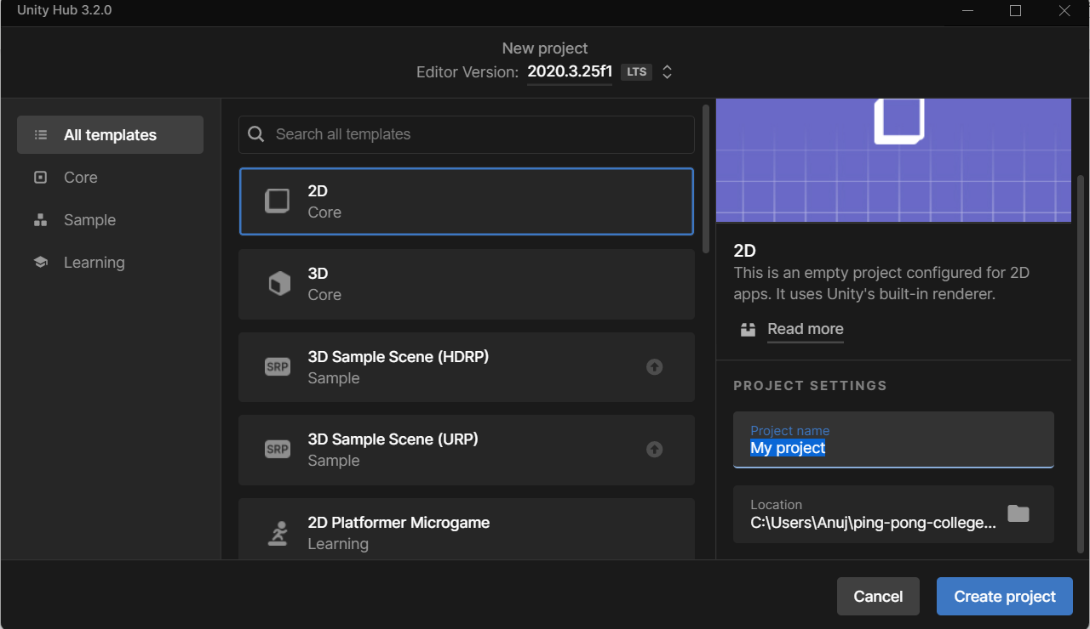

1. A new unity project will be created. Now click on Main Camera in Hierarchy.

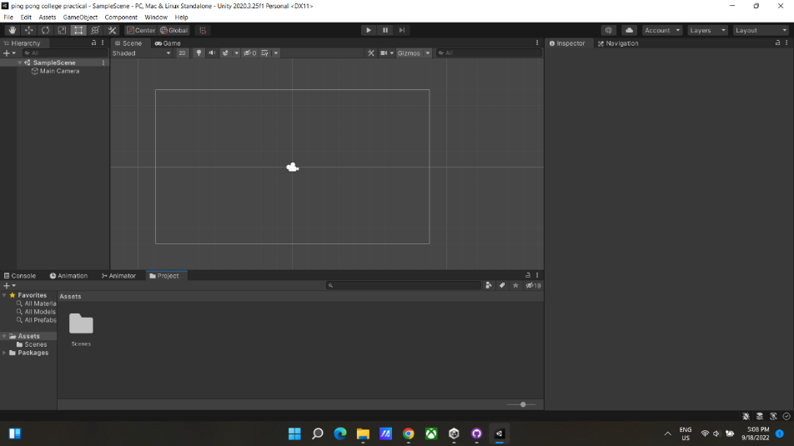

1. In inspector tab, check for background in camera component and change the background color to black.

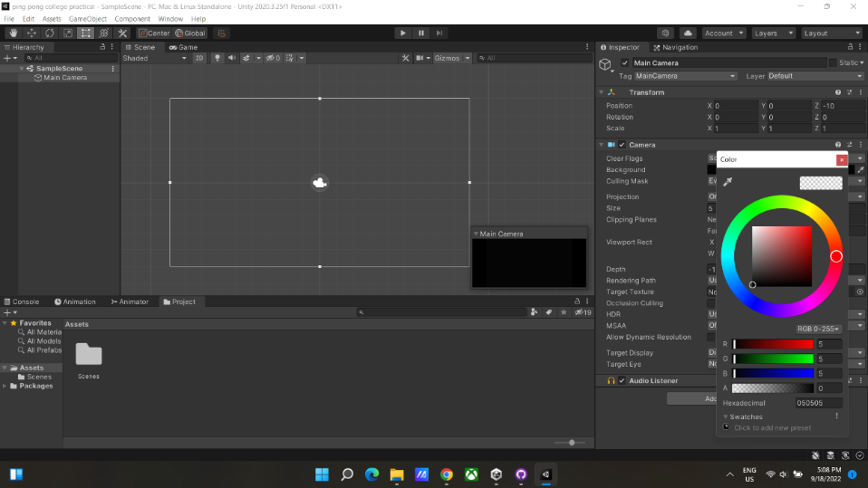

1. Now, click on the assets folder in project tab. Right click and click on create -> folder.

Create 2 Folder

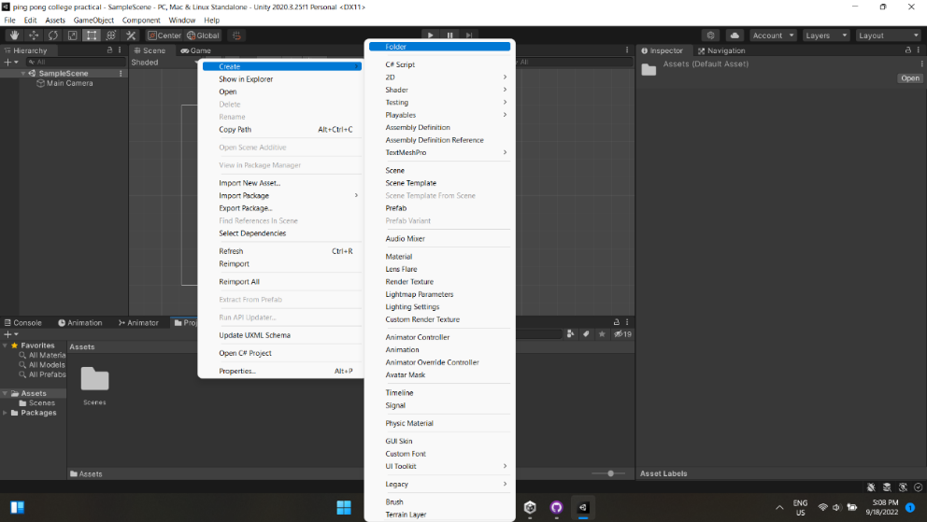

1. Create 2 folder with name “Assets” and “C# scripts”.

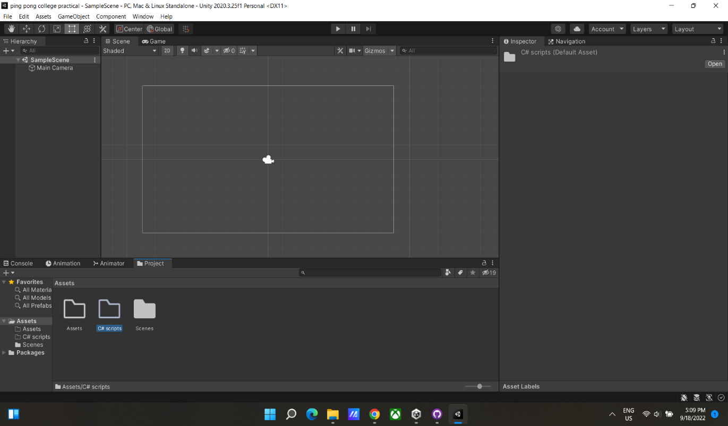

1. Now go into the assets folder. Right click -> create -> 2D -> Sprites -> Circle. And

Right click -> create -> 2D -> Sprites -> Square.

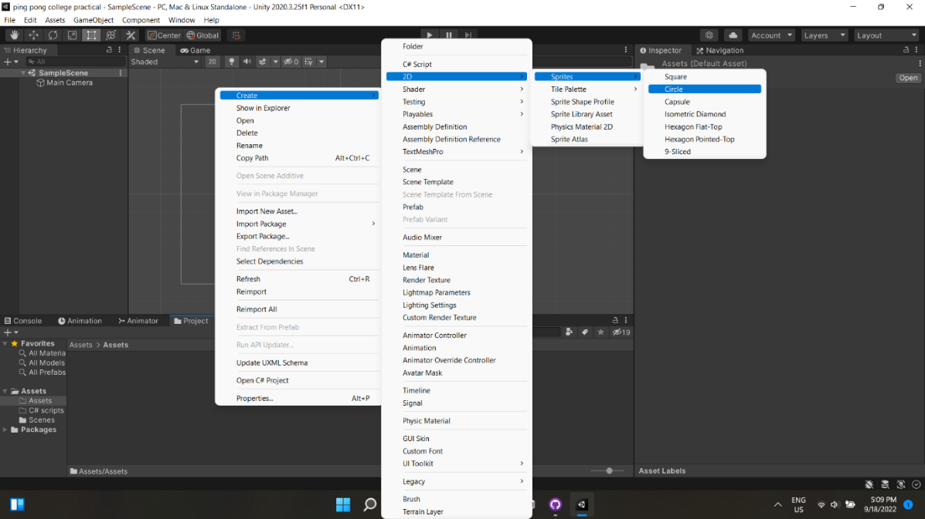

1. Now drag and drop the square in Scene view. And adjust the size and arrange the 4 Squares as shown in the screenshot below.

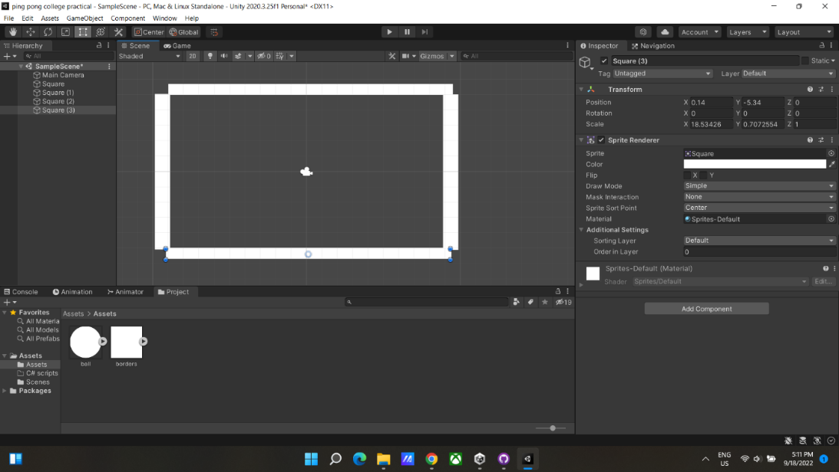

1. And rename them accordingly

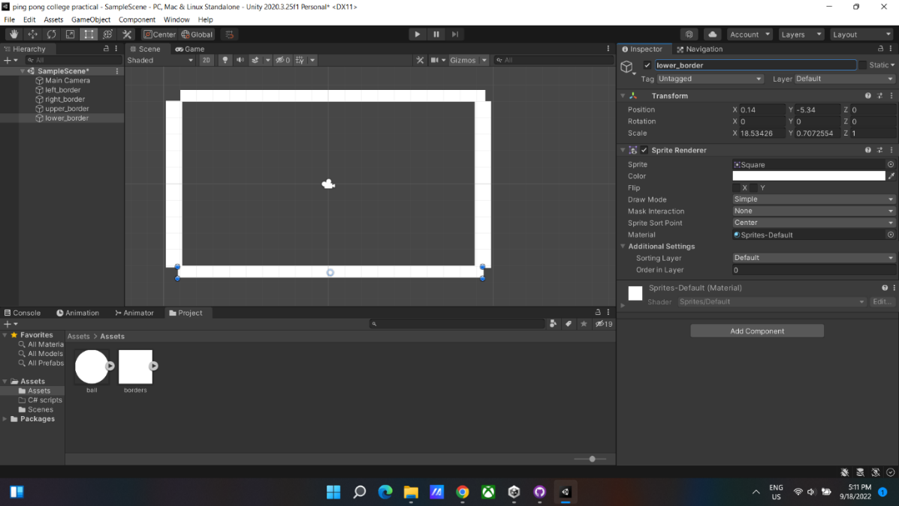

1. Drag one more square in the center of the scene view as shown in the screenshot below.

In the inspector tab -> In sprite rendered component -> select color -> and set the Alpha value to 54.

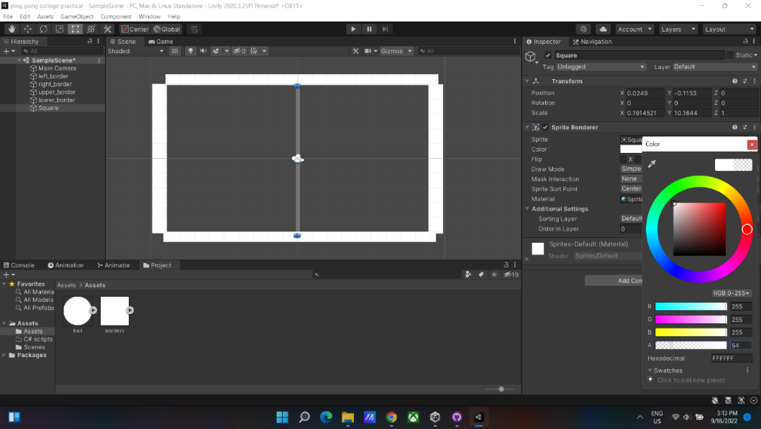

1. Drag two more square for paddle and adjust as shown in the screenshot.

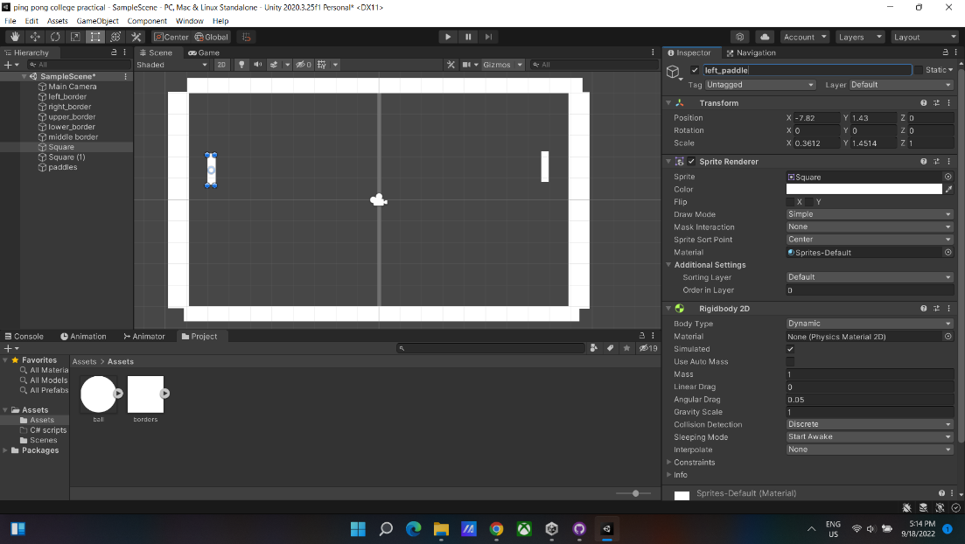

1. Create an empty game object by right clicking in the hierarchy and selecting Create empty.

Name it paddle. And drag the two paddle objects in the paddle game object.

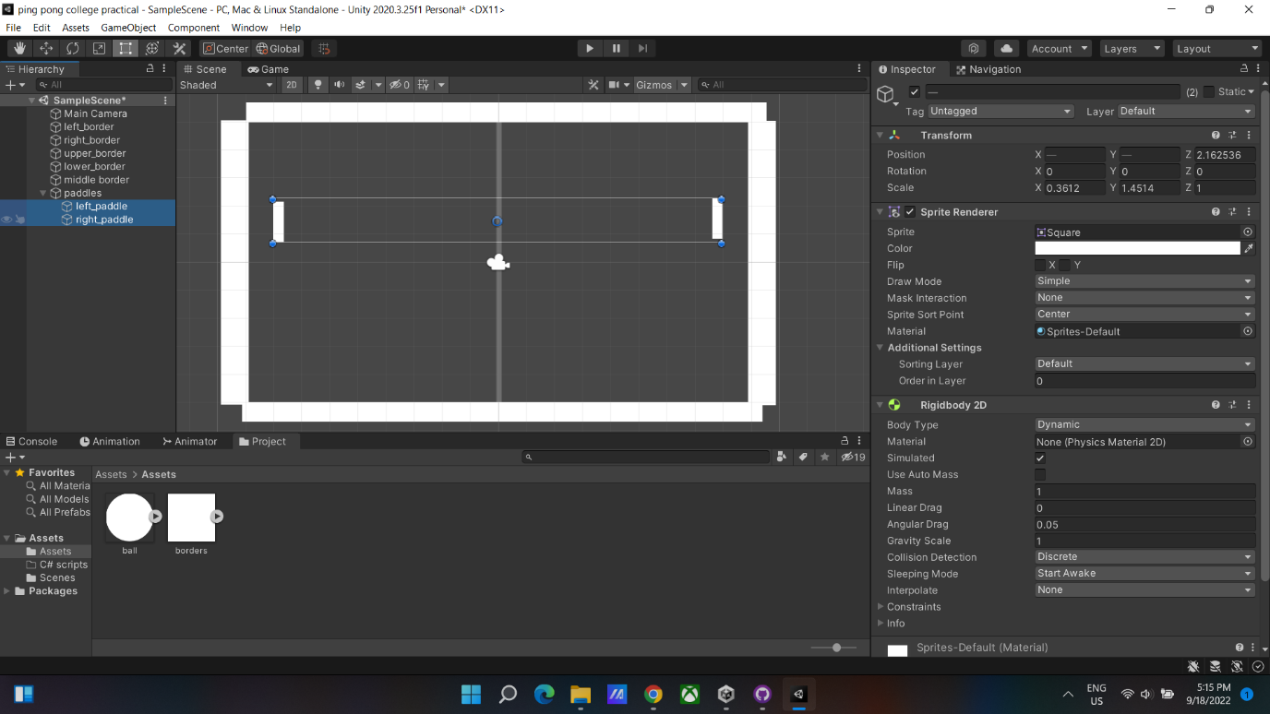

1. Do the same as step 11. But Name it as Borders and drag the border objects in the Border game object.

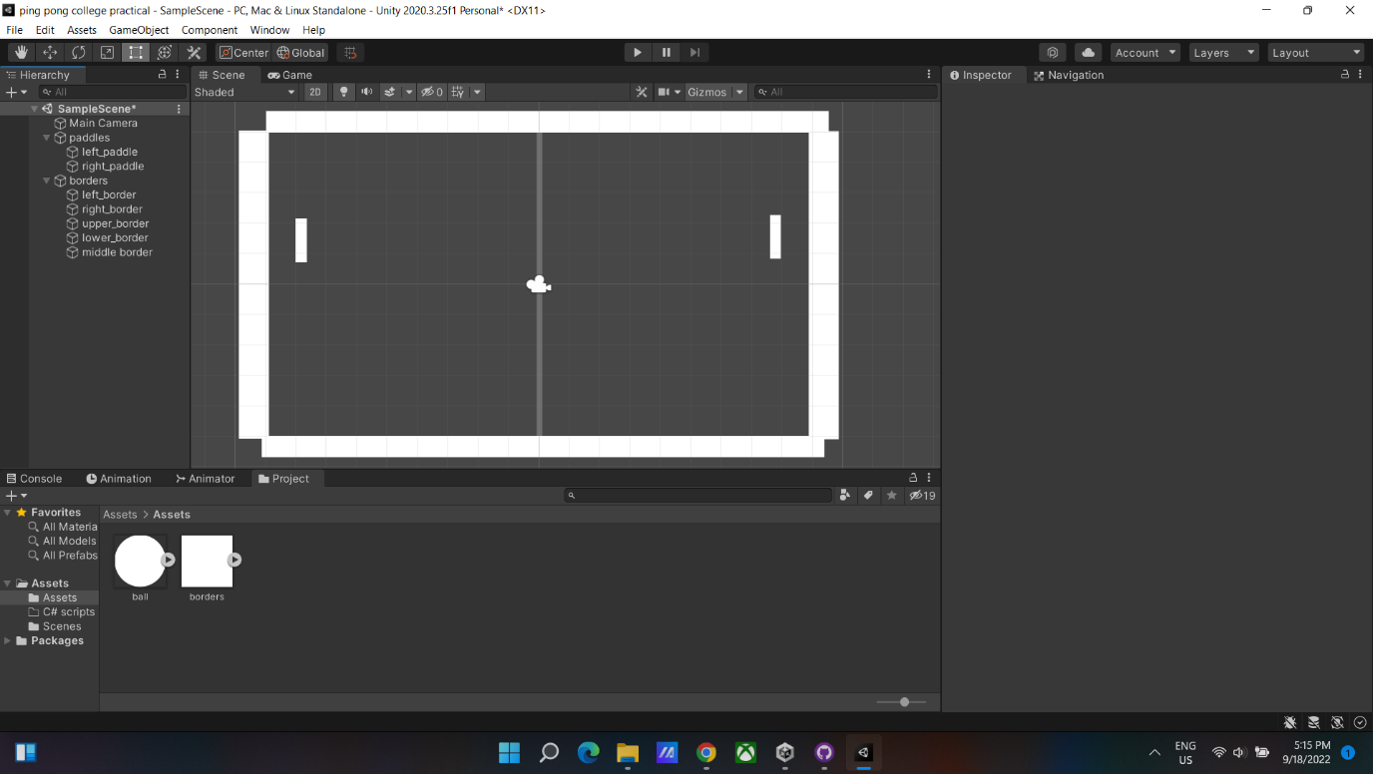

1. Drag a circle sprite from assets to scene view.

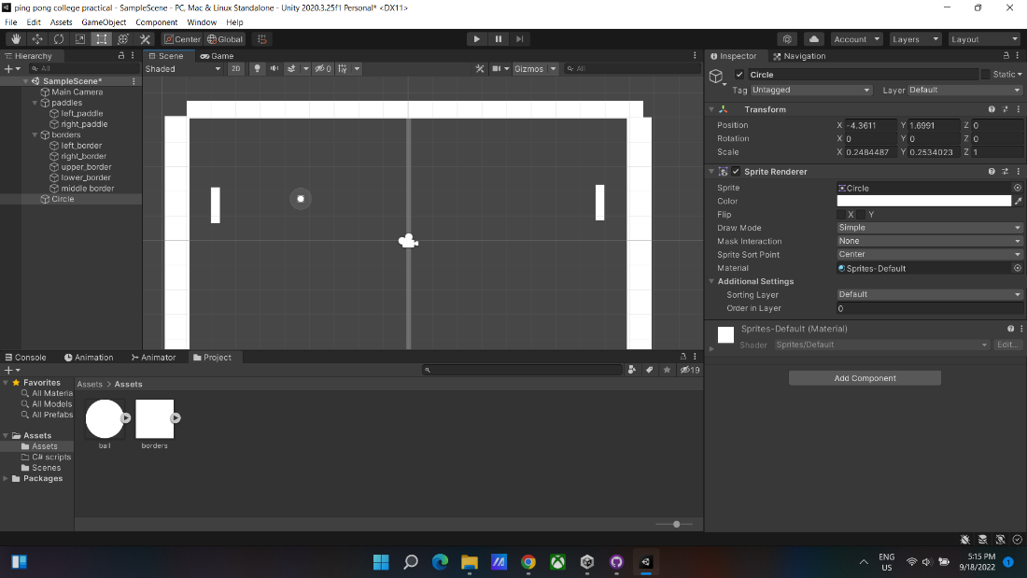

1. Add the box collider 2d and rigidbody 2d component to the paddles. Freeze the x and z constraint in the rigidbody2d.

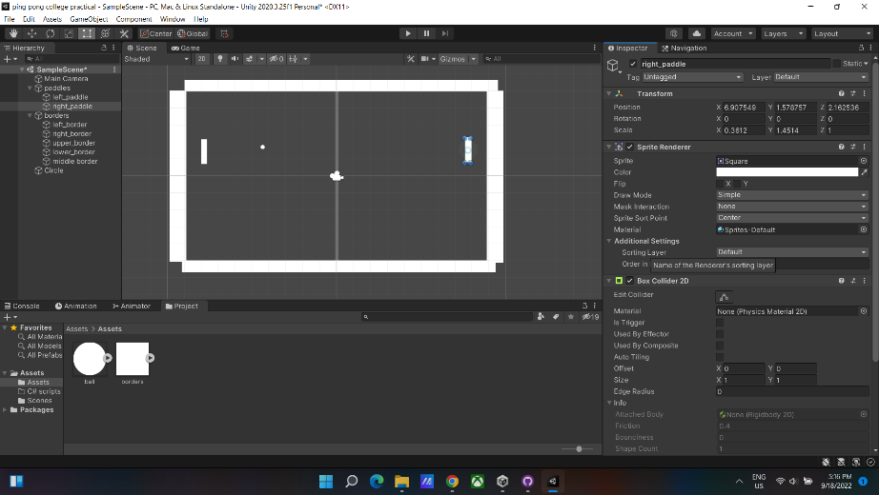

1. Do the same as Step 14, but for all the four borders.

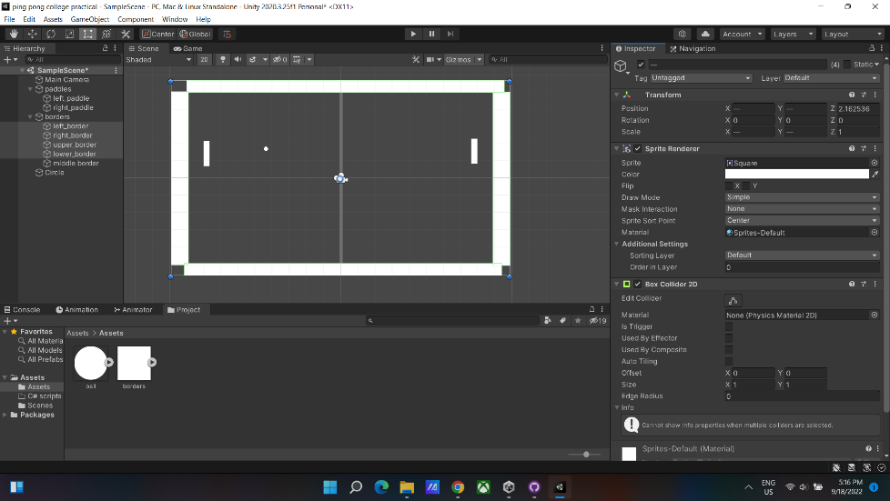

1. Do the same as Step 14, but for the ball (circle) game object.

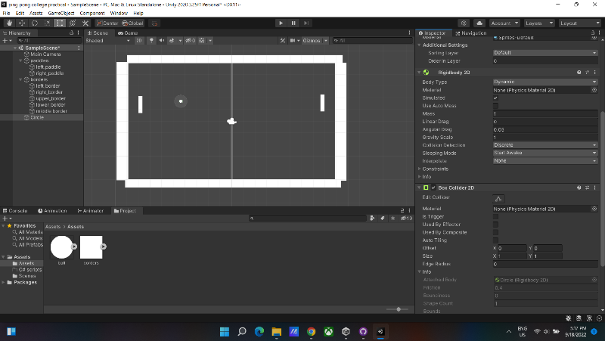

1. In the assets folder. Right click -> 2D -> physics material 2d. And give it friction of 0 and bounciness of 1.

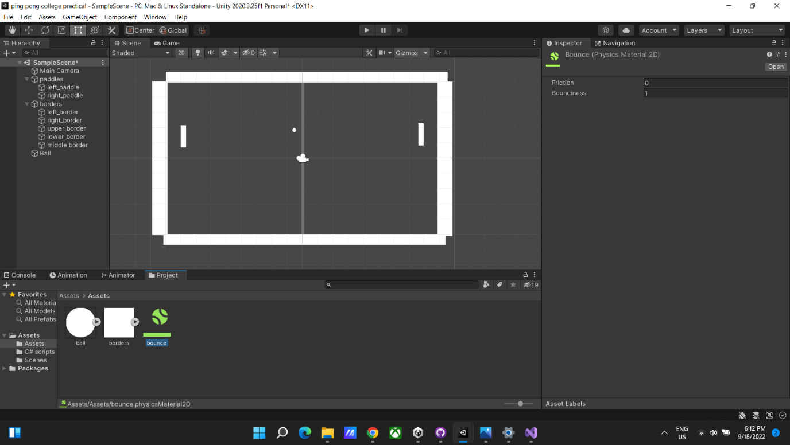

1. Add the bounce physics material to the rigid body 2d -> material of the ball.

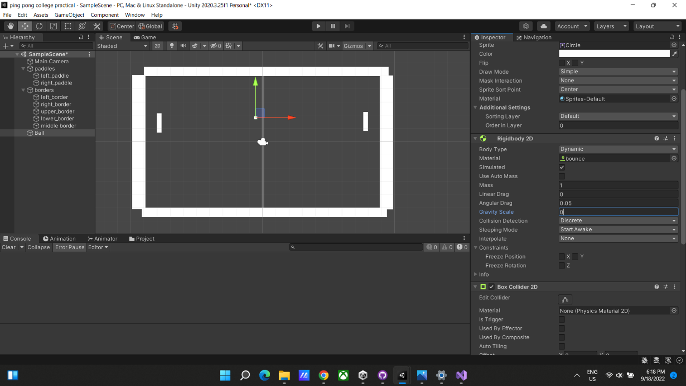

1. In the C# scripts folder. Right click-> C# script. And name it player. And do it one more time. And name it ball.

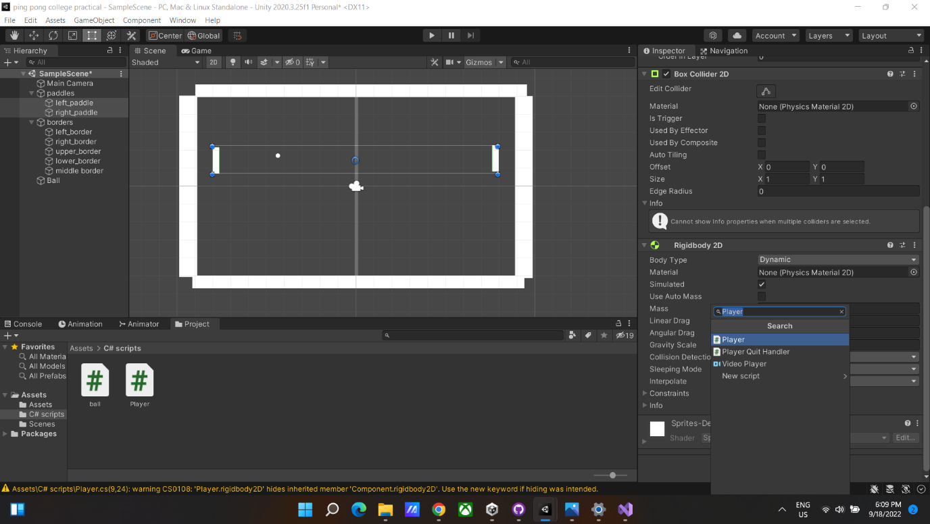

1. Add the following code for player script.

using System.Collections;

using System.Collections.Generic;

using UnityEngine;

public class Player : MonoBehaviour

{

// Start is called before the first frame update

public float speed;

public Rigidbody2D rigidbody2D;

public Vector3 startposition;

private float movement;

public bool isPlayer1;

void Start()

{

startposition = transform.position;

}

// Update is called once per frame

void Update()

{

if (isPlayer1)

{

movement = Input.GetAxisRaw("Vertical");

}

else

{

movement = Input.GetAxisRaw("Vertical2");

}

rigidbody2D.velocity = new Vector2(0, movement * speed);

}

public void Reset()

{

rigidbody2D.velocity = Vector2.zero;

transform.position = startposition;

}

}

1. Add the following code for ball script.

using System.Collections;

using System.Collections.Generic;

using UnityEngine;

public class ball : MonoBehaviour

{

public Rigidbody2D rigidbody;

public float speed;

public Vector3 startPosition;

// Start is called before the first frame update

void Start()

{

Play();

}

public void Reset()

{

rigidbody.velocity = Vector2.zero;

transform.position = startPosition;

Play();

}

void Play()

{

float x = Random.Range(0, 2) == 0 ? -1 : 1;

float y = Random.Range(0, 2) == 0 ? -1 : 1;

rigidbody.velocity = new Vector2(speed * x, speed * y);

}

}

1. Add three more scripts in C# scripts folder and name it AddScore1, AddScore2 and Score. Add the following code for Score script.

using System.Collections;

using System.Collections.Generic;

using UnityEngine;

using UnityEngine.UI;

public class Score : MonoBehaviour

{

// Start is called before the first frame update

public Text player1Score;

public Text player2Score;

private int player1Points =0;

private int player2Points =0;

int addScore1 = 0;

int addScore2 = 0;

void Start()

{

Debug.Log("Score Added");

player1Score.text = "Player 1 :" + 0;

player2Score.text = "Player 2 :" + 0;

}

public void updateScore1(int playerScore1)

{

player1Score.text = "Player 1 : " + playerScore1.ToString();

}

public void updateScore2(int playerScore2)

{

player2Score.text = "Player 2: " + playerScore2.ToString();

}

public void AddScore1(int points)

{

addScore1 += points;

updateScore1(addScore1);

ResetPosition();

}

public void AddScore2(int points)

{

addScore2 += points;

updateScore2(addScore2);

ResetPosition();

}

private void ResetPosition()

{

GameObject.Find("Ball").GetComponent<ball>().Reset();

GameObject.Find("left_paddle").GetComponent<Player>().Reset();

GameObject.Find("right_paddle").GetComponent<Player>().Reset();

}

}

1. Add the following code for AddScore1 script.

using System.Collections;

using System.Collections.Generic;

using UnityEngine;

public class addScore1 : MonoBehaviour

{

private void OnCollisionEnter2D(Collision2D collision)

{

GameObject.Find("Player1").GetComponent<Score>().AddScore1(1);

}

}

1. Add the following code for AddScore2 script.

using System.Collections;

using System.Collections.Generic;

using UnityEngine;

public class addScore2 : MonoBehaviour

{

private void OnCollisionEnter2D(Collision2D collision)

{

GameObject.Find("Player2").GetComponent<Score>().AddScore2(1);

}

}

1. Drag and drop the player scripts to the left and right paddle. And give it a speed of 10. And check the checkbox of is player 1 of the left paddle.

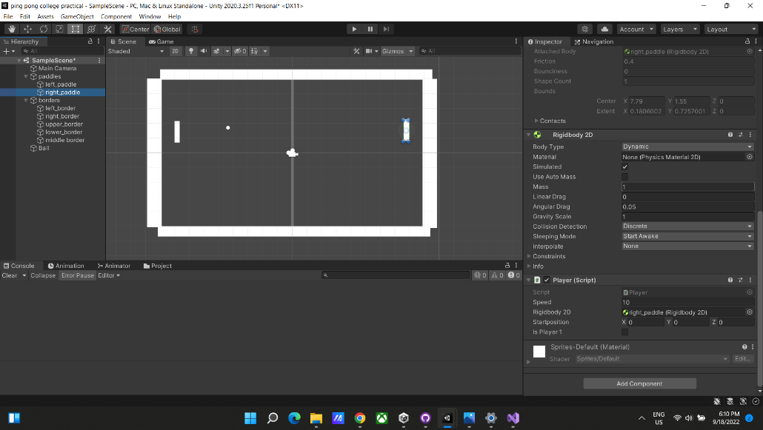

1. Drag and drop the ball script to the ball(circle) game object.

And give it a speed of 5. And select the rigidbody2d of the ball in the rigid body 2d of the ball script.

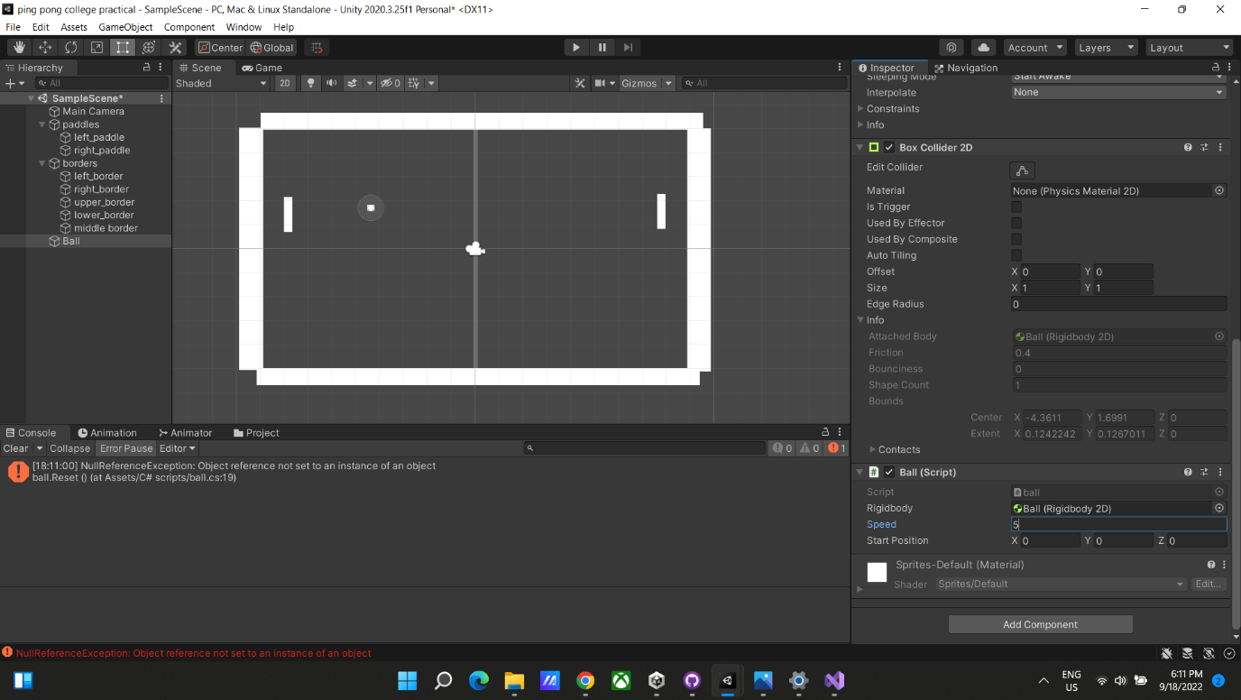

1. Create a empty game object in the game object hierarchy. And name it score. Right click -> UI -> Text. Do it twice. And name it player1 and player2.

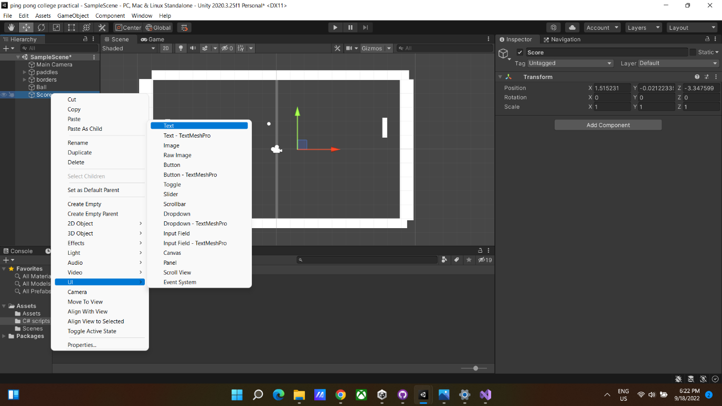 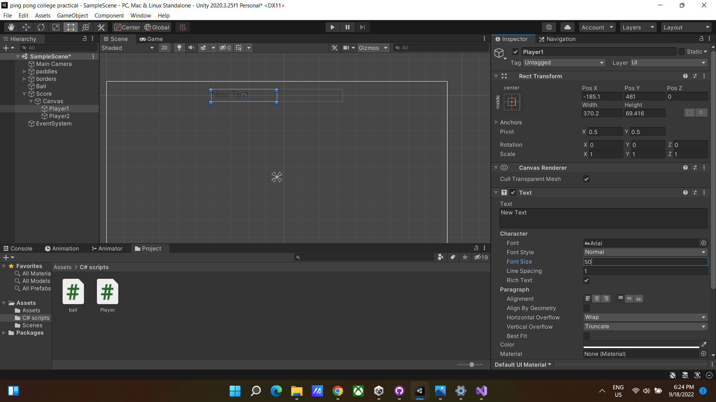

1. Arrange the score text as shown in the screenshot. Increase the font size and center the text.

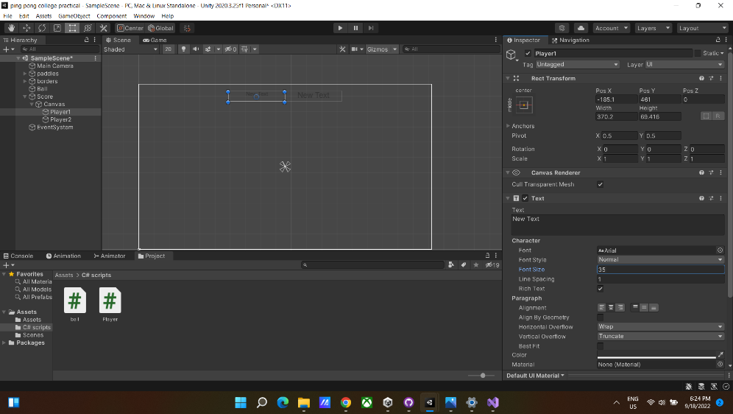

1. Drag and drop the Score script to both player 1 and player 2. And Player 1 in player 1 Score. And player 2 in player 2 Score.

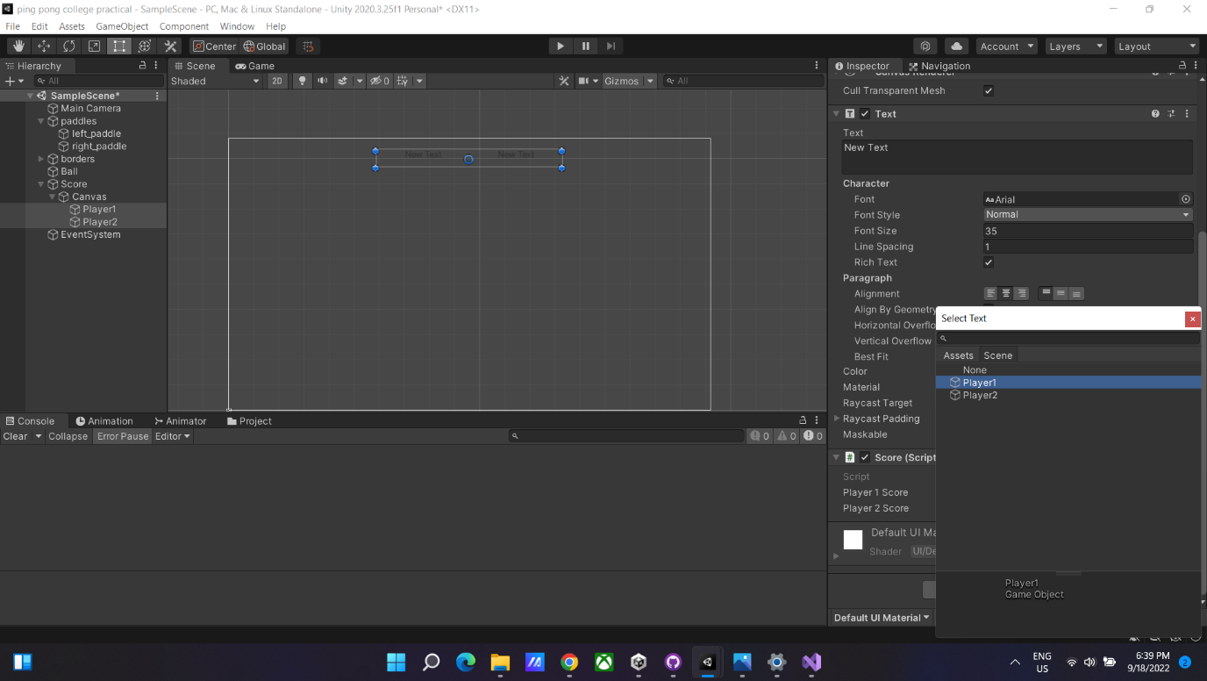

1. Drag and drop the AddScore1 to left border. And AddScore2 to right border.

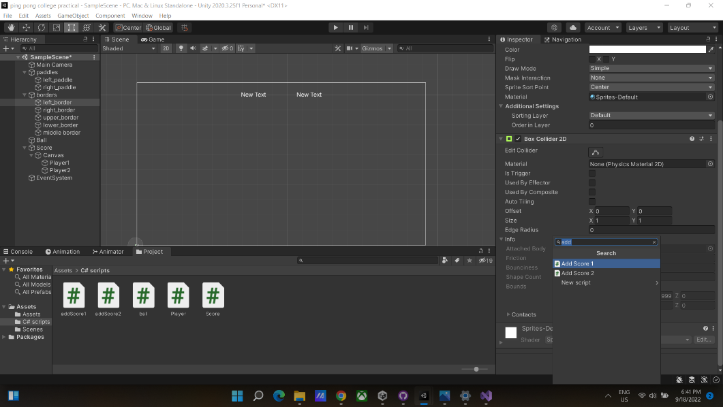

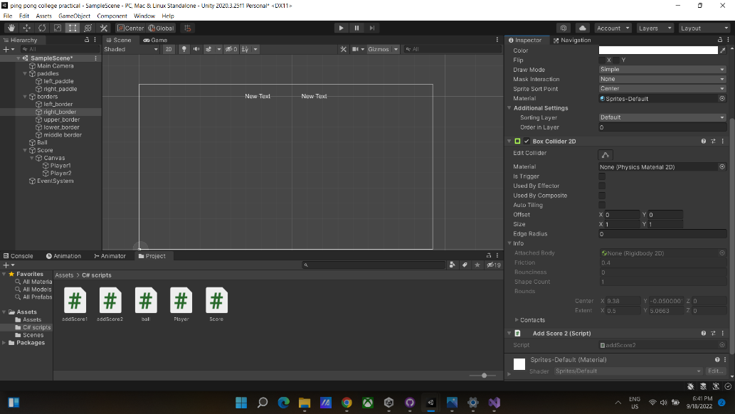

1. Click on Play button And Play the game :)

